FOR IMMEDIATE RELEASE

LG LAUNCHES NEW 27- AND 34-INCH
ALL-IN-ONE THIN CLIENTS

Powerful New Cloud-based Workstation Options
Optimized for Both Remote and In-Office Employees

LINCOLNSHIRE, Ill., June 25, 2020 – LG Business Solutions USA has introduced two new all-in-one Thin Client solutions, a 27-inch 16:9 model and a 34-inch 21:9 ultrawide model, each with full HD resolution, IPS panels and quad-core Intel® processors that make them ideal workstations for demanding corporate environments. According to Stephen K. Hu, Senior Director of Sales, National Resellers at LG Business Solutions USA, these new Thin Client models offer businesses and their employees superior performance, data security, reliability and cloud-ready connectivity for any work environment, from the trading floor to the home office.

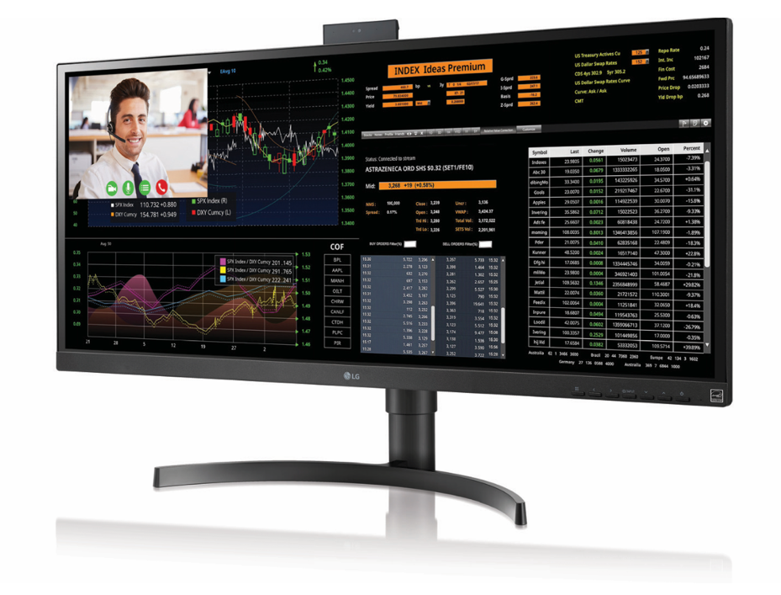
“LG Thin Client PCs are space-saving workhorse computers, and these two new models provide more flexibility and choice for business owners to address a variety of needs for various employees," Hu said. “Businesses can benefit from LG Thin Clients’ various connectivity options and simplified deployment needs while enabling more efficient use of desk space.”

Both the 27-inch (model 27CN650N-6A) and 34-inch (model 34CN650N-6A) displays deliver powerful, reliable computing with an Intel Celeron J1045 quad-core 1.5GHz processor (up to 2.5GHZ burst), integrated graphics, and a 128GB solid state hard drive. Conferencing is simple with a microphone-in port, built-in dual speakers, Wifi, Bluetooth 5.0, a pop-up HD webcam and an adjustable stand, while the fan-less design ensures quiet operation.

LG Thin Clients are simple-to-install, one-piece solutions that increase business flexibility by simplifying workspace redesigns and worker relocation, and consolidating all company data on a storage array, rather than on individual PCs. The remote capabilities make both models ideal choices for companies with employees working remotely, Hu explained.

Thin clients also are generally more secure than individual PC workstations because most programs and operations are running from a data center, not on the thin client device itself. With no access to install new programs on the server, a worker cannot accidentally introduce malware or otherwise compromising company data or systems.

To offer the most benefits to the most businesses possible, LG Thin Clients are compatible with today’s most popular VDIs (virtual desktop infrastructure), including Citrix, Amazon WorkSpaces, Microsoft Azure and VMware.

Each model houses two USB 2 ports, four USB 3 ports, one USB-C port, one HDMI input and one DisplayPort output, 1,000:1 contrast ratio, 5ms response time and 300 nit brightness. The 27-inch model offers Full HD 1080p resolution, while the Ultrawide 34-inch model has 2560x1080 pixels to deliver crisp imagery across the wider panel.

# # #

About LG Business Solutions USA
The LG Electronics USA Business Solutions division serves commercial display customers in the U.S. lodging and hospitality, digital signage, systems integration, healthcare, education, government and industrial markets. Based in Lincolnshire, Ill., with its dedicated engineering and customer support team, LG Electronics USA Business Solutions delivers business-to-business technology solutions tailored to the particular needs of business environments. LG Electronics USA Inc., based in Englewood Cliffs, N.J., is the North American subsidiary of LG Electronics Inc., a $53 billion global force in consumer electronics, mobile communications, home appliances and air solutions. LG is a 2020 ENERGY STAR® Partner of the Year-Sustained Excellence. For more information, please visit www.LGSolutions.com.

Media Contacts:

LG Electronics USA

Kim Regillio
847 941 8184
kim.regillio@lge.com

Bob Griffin
212 481 3456 x16
bob@griffin360.com

